**Practical 3**

**Prepare the following diagrams for your Project**

1. **E-R Diagram**

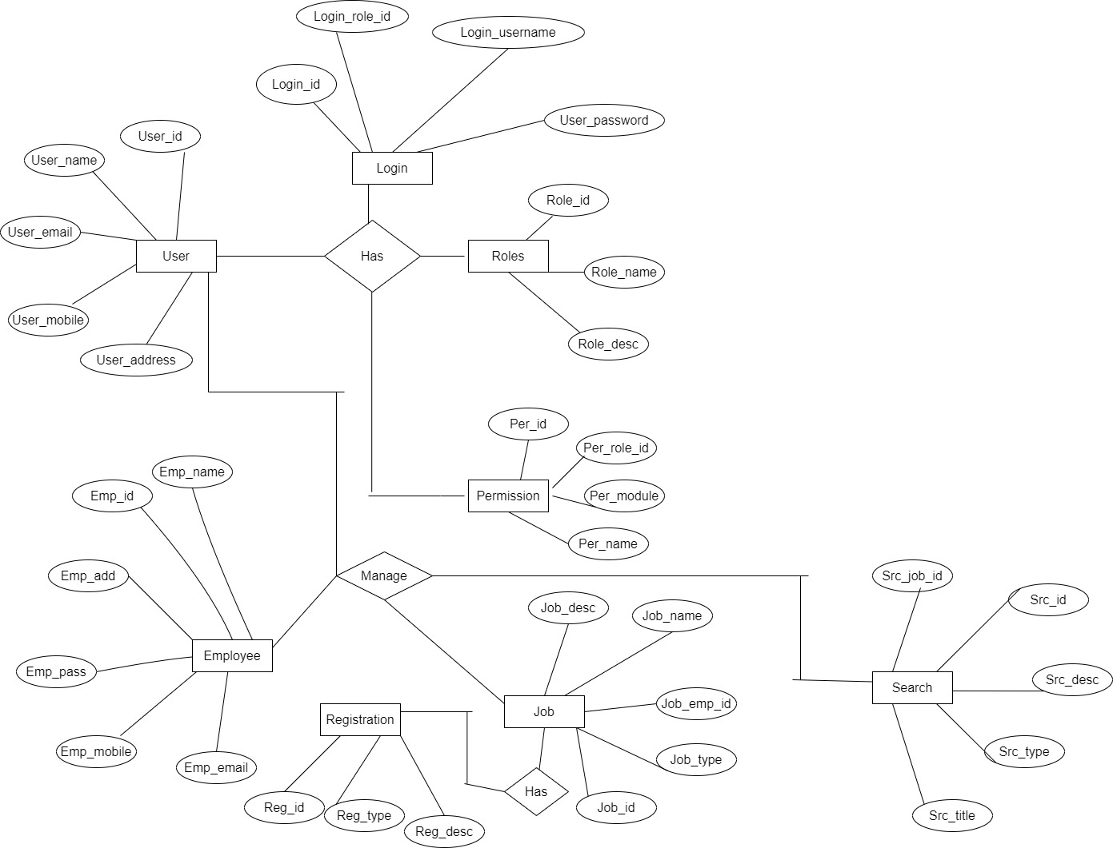

1. **Use-Case Diagram**

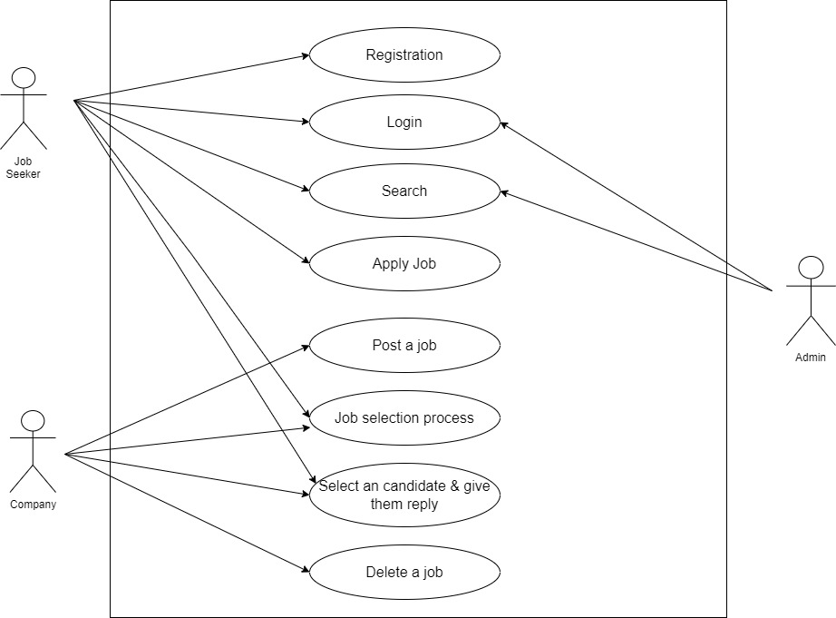

1. **Class Diagram**

